AIM- To create and execute two FreeRTOS tasks with different priorities and analyzing their effect on LED blinking behaviour.

APPARATUS- STM32 Nucleo-F446RE development board, an LED, Breadboard, Connecting wire, Resistance, USB Type-A to Mini-B cable, STM32 CUBE IDE, STM32 CubeMX.

THEORY
FreeRTOS implements preemptive priority-based scheduling where tasks with higher priority values (e.g., osPriorityHigh > osPriorityNormal > osPriorityLow) execute immediately when they become Ready, preempting lower-priority tasks even mid-execution. In this experiment, two tasks with identical osDelay(500) periods are assigned different priority levels via CMSIS-RTOS v2 task attributes, demonstrating how the scheduler favours higher-priority tasks for CPU allocation. When both tasks block cooperatively via osDelay(), lower-priority tasks still execute periodically; however, as priority differences increase, the lower-priority task experiences progressive CPU starvation, observable through reduced LED blinking rates and decreased message frequency in the SWV ITM console. This illustrates the fundamental trade-off between priority responsiveness and fairness in real-time systems.
PROCEDURE

- Open CubeMX and Click on ACCESS TO MCU SELECTOR.

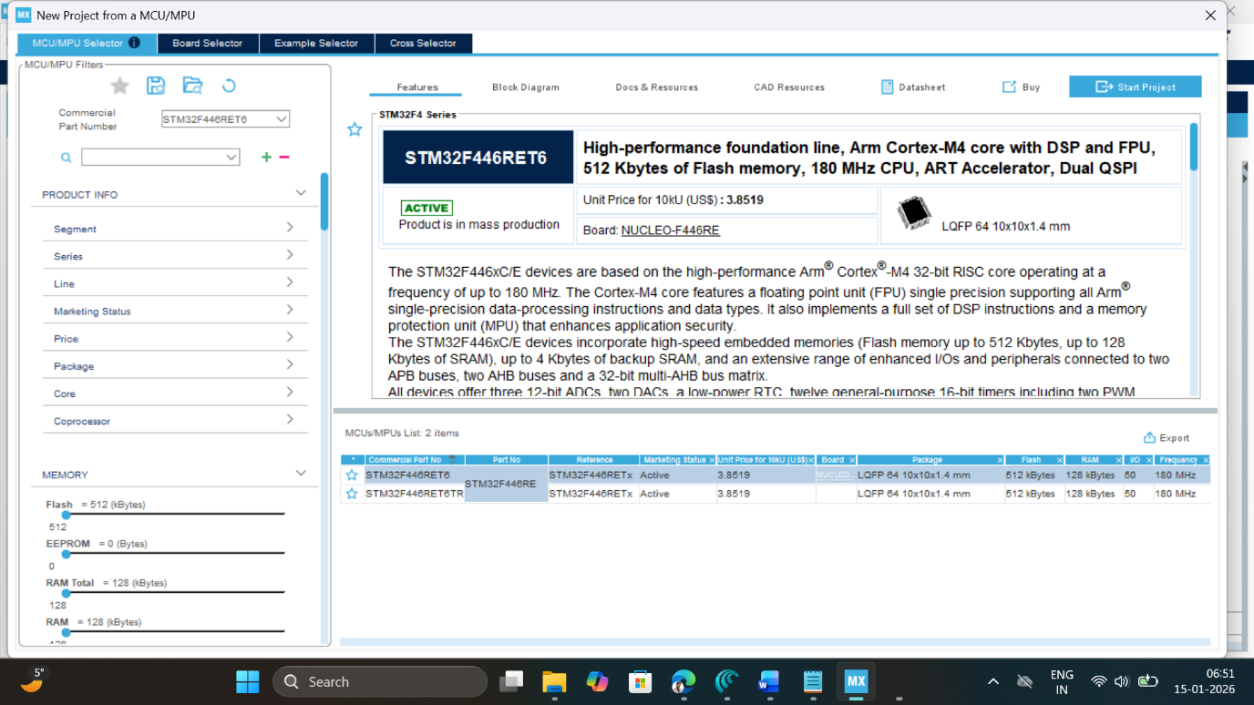

- Write and select the microcontroller as you want to use and then click start the project. Select commercial part number STM32L446RE.
- In system Core select GPIO and right click on pin PA5 and PA6 to make it as GPIO output pin.
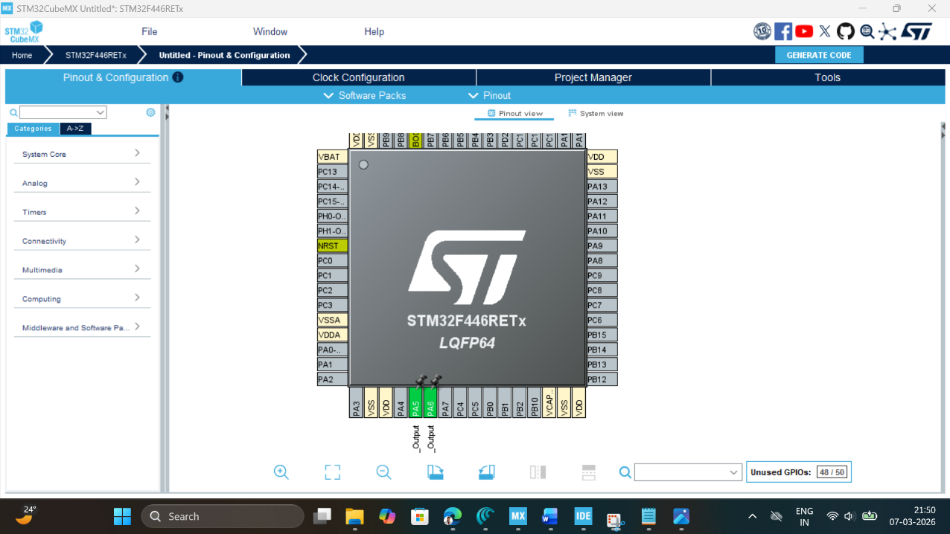

- Clock Configuration: Configure clock as shown below to get maximum internal clock frequency of 84MHz.
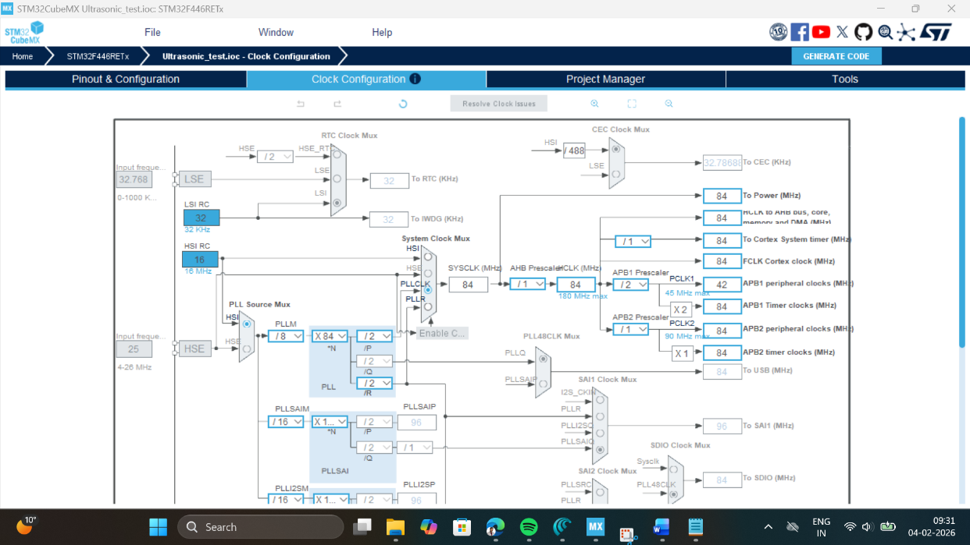

- SYS Mode: Click on SYS mode and select debug as Trace Asynchronous Sw, and Timebase source to TIM6.
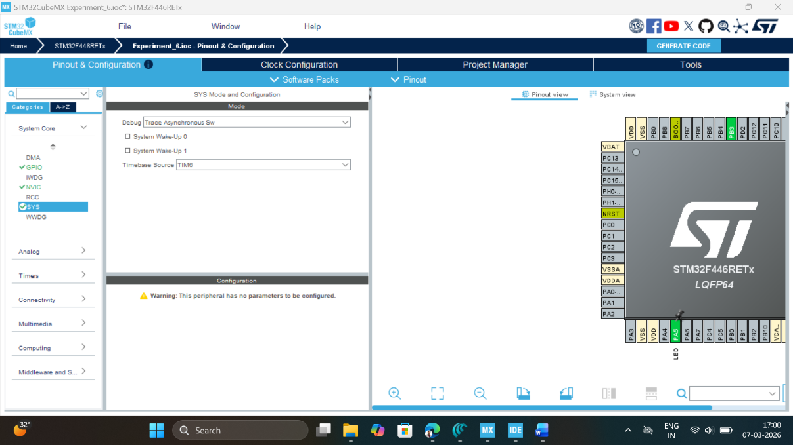

- FreeRTOS Configuration: Click on Middleware and Software Pack, then select FreeRTOS software pack, which is already available with STMCube Mx. Select interface as CMSIS_V2.
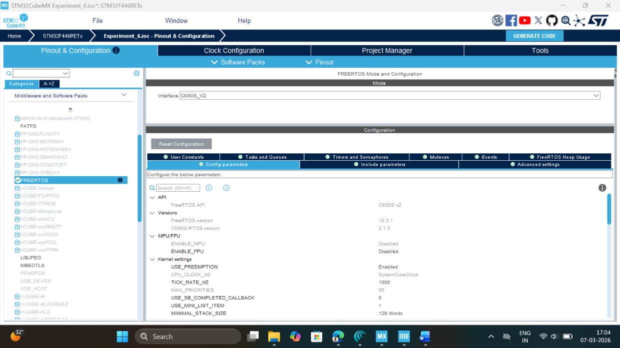

- Click on Task & Queue Tab of configuration setting and create two tasks as LED_1 and LED_2 as shown below. Keep priority of both tasks same.
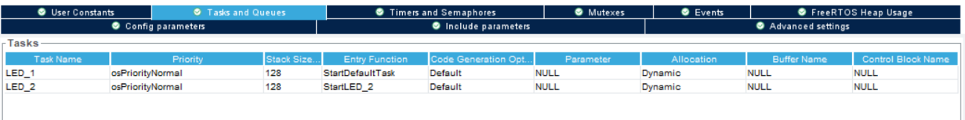
- Write Project name and select IDE.
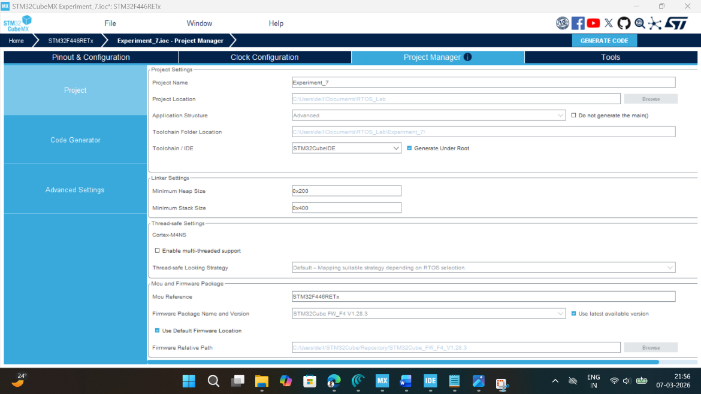

- Click on generate code.
- Click on open project.
- Click ‘OK’ on the generated popup showing “successfully imported the project on the workspace” and the project will be successfully added to the cube IDE.
- Open the main source code on Cube IDE by clicking on main.c
- Click on project properties, go to C/C++ Build settings check box for printf and scanf settings.
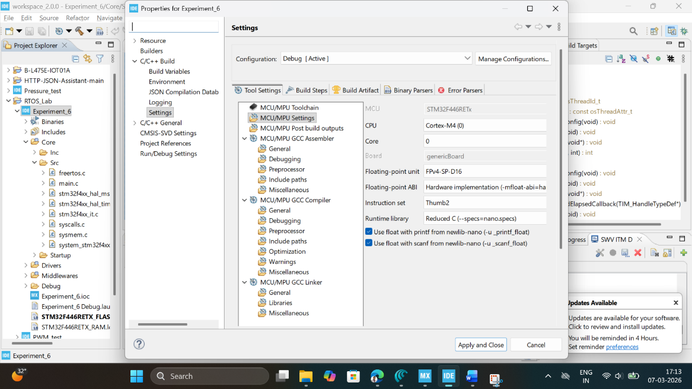

- Now click on Debug icon and configure debugger for SWV ITM Trace



- Click on Debugger configuration, select debugger console, and click on ST-LINK S/N and then scan, as we attach a STM32F446RE development board, it will automatically pick up ST-LINK id.
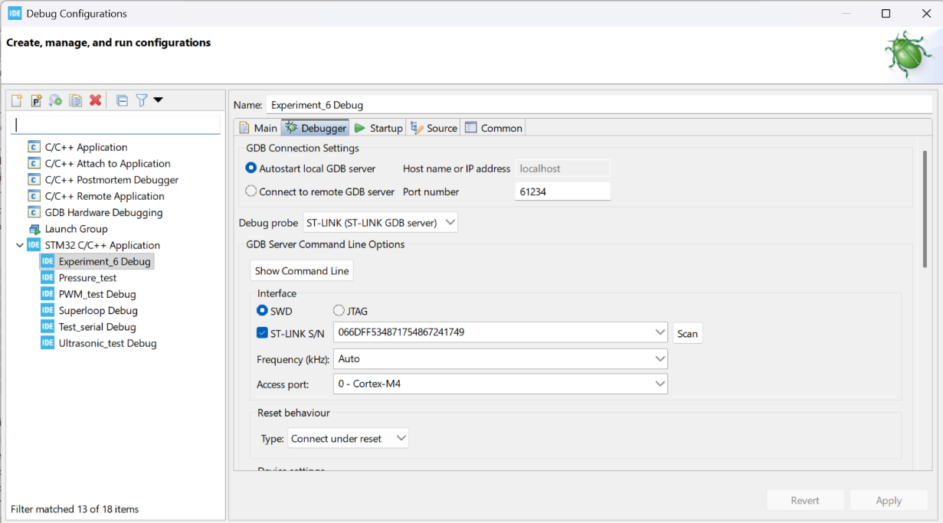

- Next, select the Serial Wire Viewer (SWV) and check box on enable button and make sure to pass on the right core clock frequency which is set-up at per point 4 here i.e. 84MHz. Then click on Apply button and close this window.
- After configuration write following instructions in the main.c file and compile the program and ensure there will be zero error after compiling.

/* USER CODE BEGIN Includes */

#include <stdio.h>

/* USER CODE END Includes */

Write the function to enable SWV ITM Console to trace the output of Task_1

/* USER CODE BEGIN 0 */
// Retarget fwrite to ITM
int _write(int file, char *ptr, int len) {
for (int i = 0; i < len; i++) {
ITM_SendChar(*ptr++);
}
return len;
}
/* USER CODE END 0 */

Edit the Task_1 and Task_2 function as given below to toggle the inbuilt LED for 500ms delay.

* USER CODE END Header_Task1_function */
void Task1_function(void *argument)
{
/* USER CODE BEGIN 5 */
/* Infinite loop */
for(;;)
{
HAL_GPIO_TogglePin(GPIOA, GPIO_PIN_5);
printf("Task_1 Executing for LED Toggle \n");
osDelay(500);
}
}

void StartLED_2(void *argument)
{
/* USER CODE BEGIN StartLED_2 */
/* Infinite loop */
for(;;)
{
HAL_GPIO_TogglePin(GPIOA, GPIO_PIN_6);
printf("Task_2 Executing for LED Toggle \n");
osDelay(500);

}
/* USER CODE END StartLED_2 */
}

/* USER CODE END 5 */

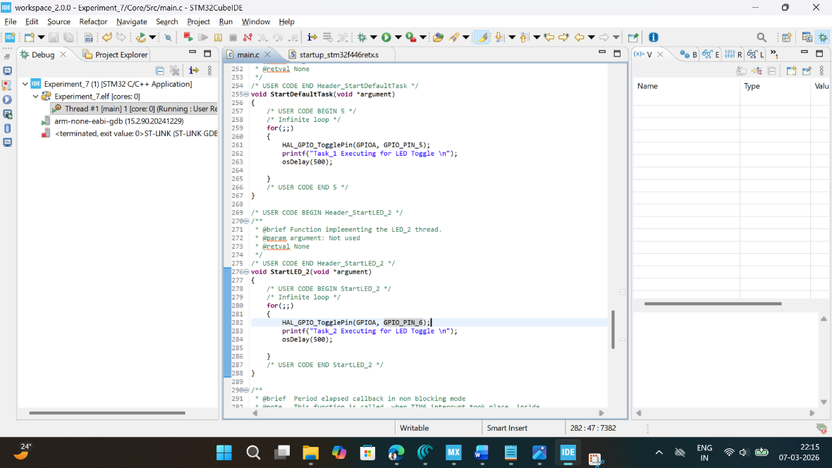

- Now, click on Window tab, select show view other select SWV ITM Data Console.
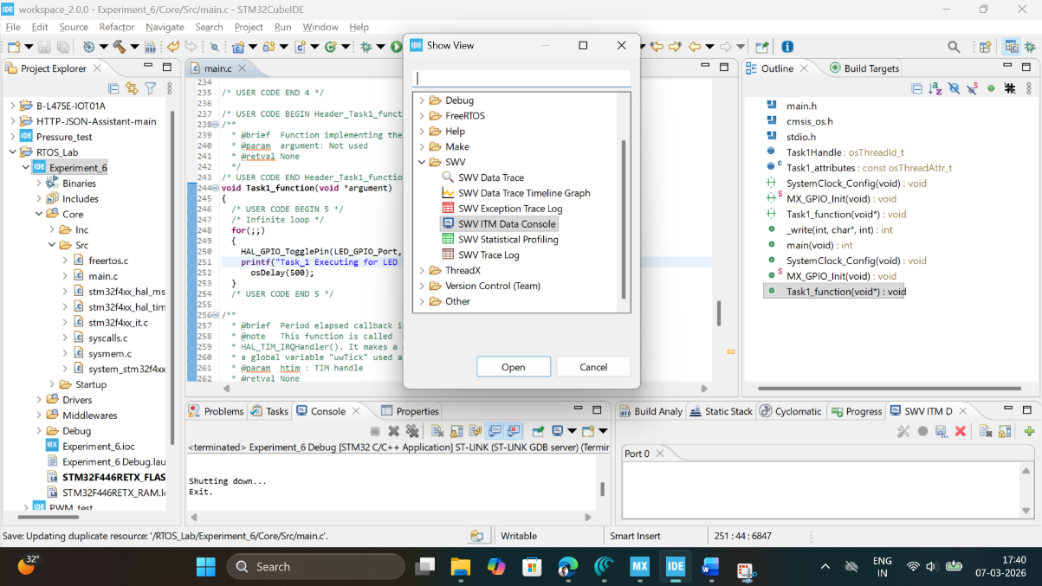
- Now click on Debug button, start debugging this main.c file and click on switch to change the perspective to debugger.
- Click on SWV ITM Data Console setting, enable the PC sampling and select port 0.
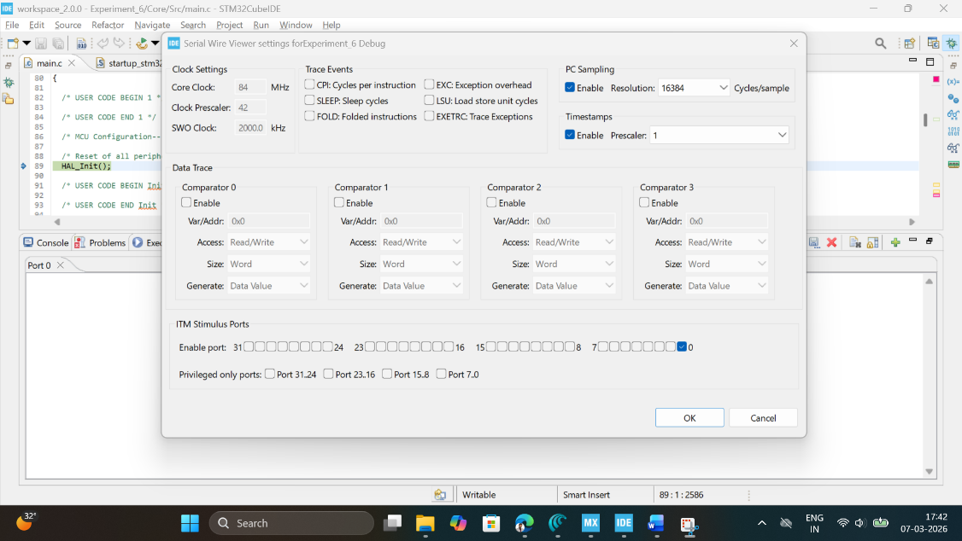
- Click on Start Trace (Red Dot) on SWV ITM Data Console tab and then click on resume button to start executing the main program. Now you can see the message on Port 0 and LED Toggle on STM32F446RE development board.
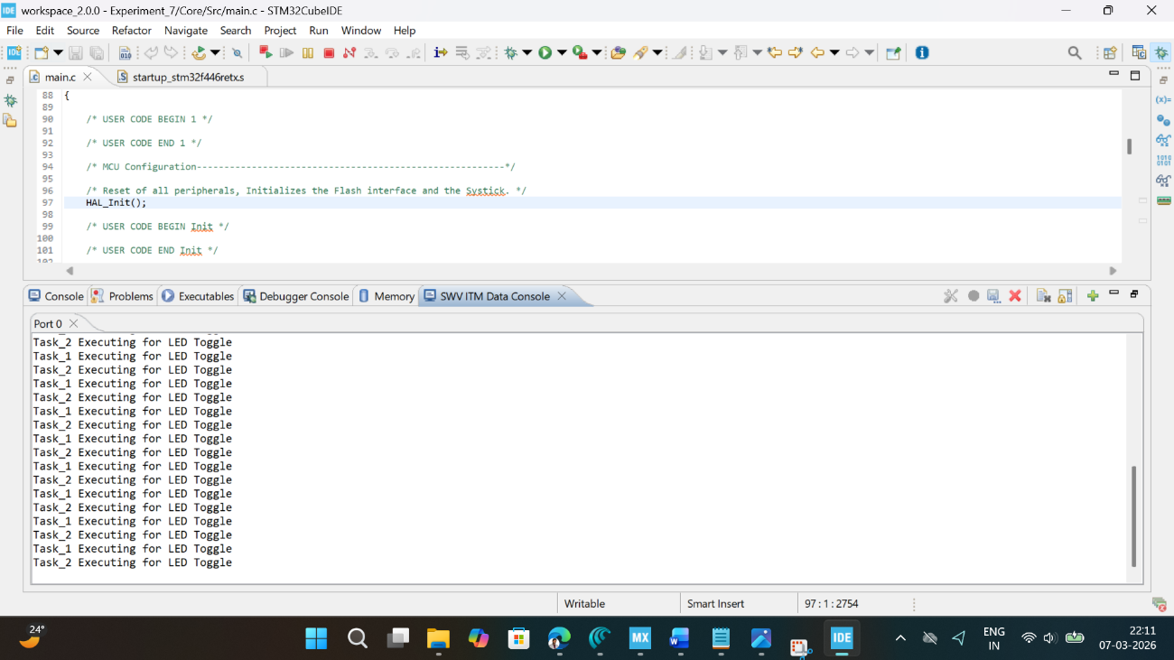

OBSERVATION:
S. No | Task_1 Priority | Task_2 Priority | LED_1 Blink  rate (Hz) | LED_2 Blink  rate (Hz) | SWV Console message | Remarks
1 | osPriorityLow | osPriorityLow | SAME | SAME | Both running | Task 1 & Task 2 runs  simultaneously
2 | osPriorityNormal | osPriorityLow | FASTER | SLOWER | Task 1 more active | Task 1 runs before  Task2 .
3 | osPriorityHigh | osPriorityNormal | MUCH  FASTER | SLOW  DELAYED | Task 1 mostly runs | Task 1 runs faster and  Before Task 2
4 | osPriorityRealtime | osPriorityNormal | VERY  FASTER | NEARLY  BLINKS | Task 1 only runs | Only task 1 runs and  Task 2 runs Hardly
5 | osPriorityError | osPriorityLow | NO BLINK | NORMAL  BLINK | Error shown | Task 1 dose’nt run  Task 2 runs normally

RESULT
The two tasks were created using FreeRTOS Middleware software pack using CMSIS V2 interface and the output of two tasks is observed using SWV ITM Data console Port 0 and anlyzed for different task priorities.

Reflection Summary

1. How does the scheduler share CPU time between two tasks of equal priority that both call `osDelay(500)`, and what evidence do you see of this in the LED blinking pattern and SWV ITM output?

Ans - When two tasks have the same priority and both use osDelay(500), the scheduler shares CPU time by letting them run one after the other in a fair manner. Each task runs for a short time, performs its work (like toggling an LED), and then goes into a 500 ms delay, giving the other task a chance to run. This creates a turn-by-turn execution, so neither task dominates the CPU. As a result, both LEDs blink at almost the same speed, though they may not be perfectly in sync because they are not running at the exact same moment. In the SWV ITM output, this behavior is visible as messages alternating between Task 1 and Task 2, showing that the scheduler is switching between them regularly.

2. If one of the tasks had no `osDelay()` or blocking call, how would this affect the execution of the other task, and what would you expect to observe on the LEDs and in the console messages?

Ans- If one task does not use osDelay() or any pause, it keeps running again and again without stopping. Because of this, it does not give the CPU to the other task. So basically, it becomes greedy and takes almost all the processing time.
As a result, the LED of this task will blink very fast or may look like it is always ON, while the other LED will blink very slowly or may not blink at all. In the console (SWV output), you will mostly see messages from the task without delay repeating continuously, and very few or no messages from the other task.
In simple words, one task keeps running non-stop and does not give a chance to the other task to run properly.

3. Compare this two‑task RTOS implementation with a single super‑loop that toggles two LEDs: what advantages in structure, readability, and extensibility do you observe when using separate tasks?

Ans-In a single super-loop, everything is written in one place, which makes the code messy and harder to manage as you add more features. In an RTOS with two tasks, each LED is handled separately, so the code is cleaner and easier to read. It’s also easier to modify or add new tasks without affecting others. Overall, RTOS makes the program more organized and flexible compared to a super-loop.

4. How does SWV ITM tracing support the verification of correct RTOS behaviour (task execution order, timing, liveness) without adding extra GPIO pins or UART peripherals?

Ans- SWV ITM tracing helps you check RTOS behavior by sending debug messages directly from the microcontroller to your PC through the debug interface, so you don’t need extra GPIO pins or UART. By printing messages inside each task, you can see the order in which tasks run, how often they run, and whether they are still active. If the messages appear in the correct sequence and timing, it means your scheduler is working properly. If one task’s messages are missing or delayed, you can immediately spot problems like starvation or blocking. In simple words, it lets you “see” what the CPU is doing in real time without adding extra hardware.

